Ques - 1

Simulating network with switches and multiple end devices ,Using Ping to generate traffic and observing MAC address table

Pic 1 depicts the MAC address after passing ping command from PC0 to verify passing to packets through swithc

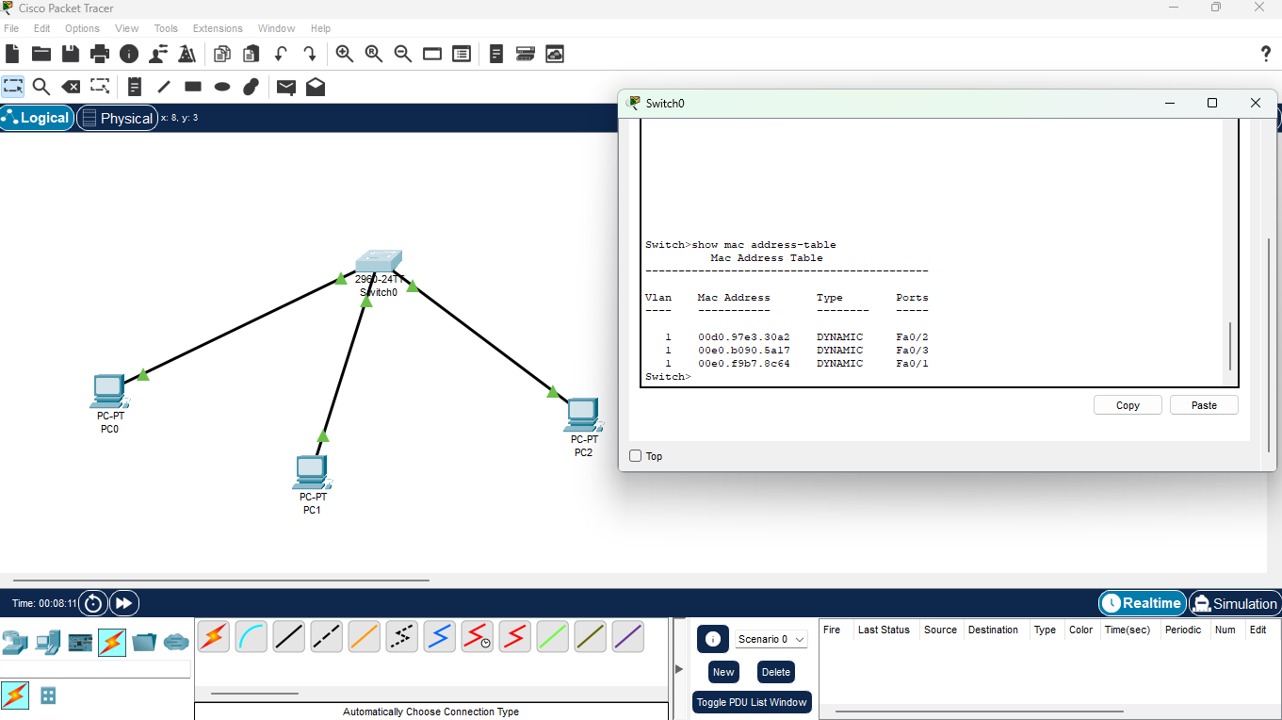

Pic 2 to Depicts the Listing of how it is passed based on the simulation of how it sent the packets and receives through end devices

